Daniel Cheon

Analyze software interface using Gestalt Principle: Kayak

Most important point in the Gestalt Principles are proximity, similarity, continuity, closure, symmetry, figure/ground, and common fate. This analyze report is about investigate how specific web site is using the Gestalt Principles.

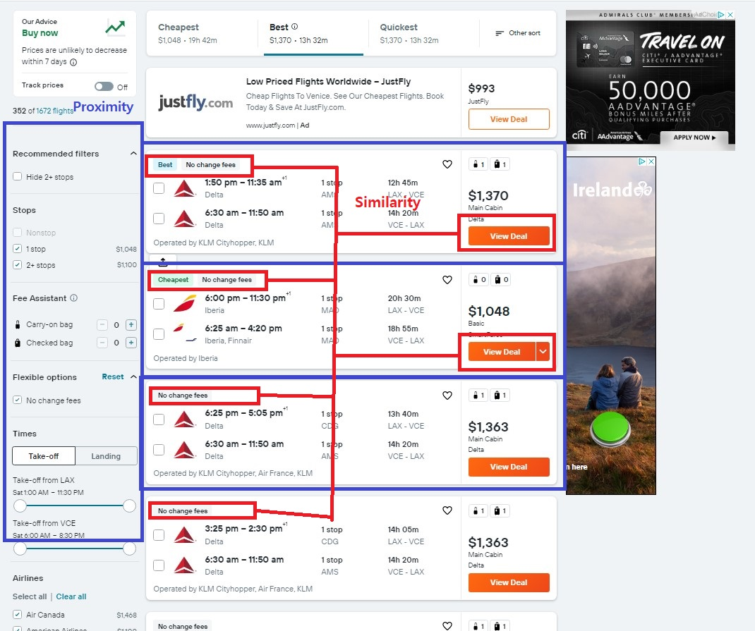

User interface in the Kayak booking website using the Proximity and Similarity in Gestalt Principles. In the red box, it applies Similarity. The Similarity in Gestalt Principles, “*Objects that look similar appear grouped, all other things being equal*”. Red boxes in left side, it shows Best, Cheapest, and no change fees boxes, it means that people can see what airline short travel time has been, what airline is cheap and what airlines have no change fees. In addition, right side of red box also shows same color of “View Deal” button, it describes people to know these buttons are about price will show up after clicked.

Second, the Gestalt Principles used in the Kayak website is Proximity. The principle said that the Proximity is relative distance between objects in a display affects our perception of whether and how the objects are organized into subgroups. In the blue box in left corner, it organizes and divides how many stops in travel, and choose onboard bag or checked bag. In the box, it made some distance few different categories. Also, the proximity can find middle of web page, which are three boxes in middle of image. These boxes provide each airline and time information. To use the Proximity and Similarity in Kayak web site provide positive effect on the user’s visual communication and user experience. Moreover, the web site uses figure and ground principle; “*separates the visual field into the figure (the foreground) and ground (the background)*”. The background of web site is light grey color and important texts are all black color and organize to emphasize information.

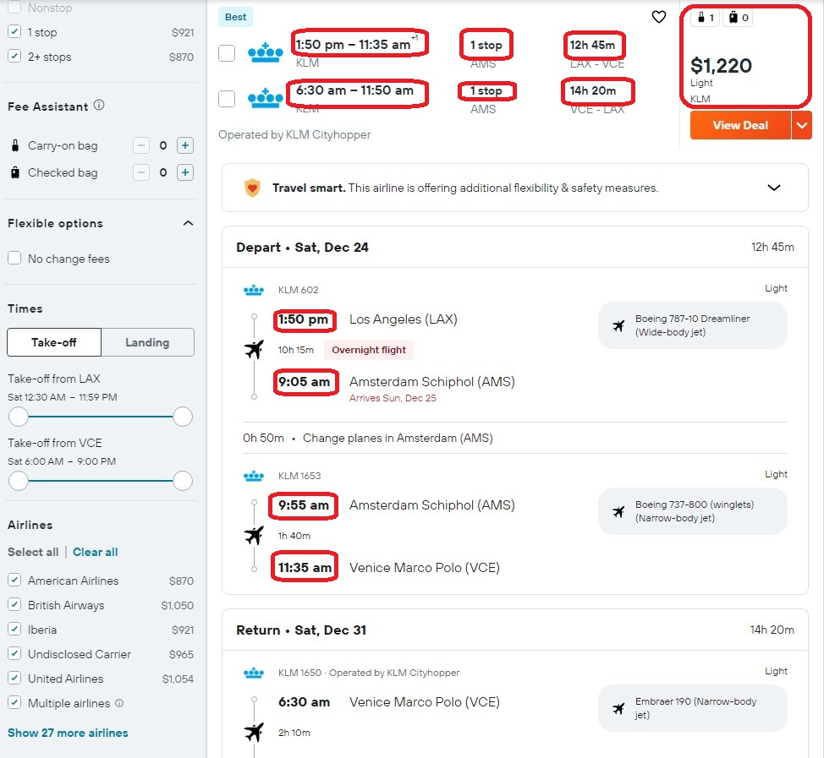

Above image shown important text, which is arrive, departure time, flight time and price. This border texts describe structured presentation of visual structure. User can easily and quick scan flight time and price, which are most important time and price.

In the last, web site needs Gestalt’s Common Region principle, “*Objects located within the same closed region are perceived as grouped together*”, then site become more improve. For example, when user click “View Deal” button, it just shows all information directly within under “View Deal” button, which are depart and return time, and includes and where traveler overnight at. However, it uses common region principle, such as if user clicked “View Deal” button, the web page display departs first, where traveler will overnight at, then next slide will return date and where overnight at. If the Kayak applies the Common Region principle, users can have great experience on this website.